**PROJECT REPORT**

**ON**

**HOTEL MANAGEMENT**

**PREPARED**

**BY**

**ROHAN PARKAR**

**JITESH NAMBIAR**

**ARUN PANDEY**

**TANMAY RAJADHYAKSHA**

**BRANCH**

**SE COMPS**

**TRAINED BY**

**RAMKUMAR SIR**

**GUIDED BY**

**PROF. VISHAL BADGUJAR**

**COLLEGE**

**A.P SHAH INSTITUTE OF TECHNOLOGY**

TABLE OF CONTENTS

* **Introduction**
* **Objective**
* **Feasibility analysis**
* Technical feasibility
* Operational feasibility
* **System requirement**
* Software details
* Hardware details
* **List of modules**
* login
* registration
* food billing
* customer details
* room booking
* payment portal
* feedback
* forgot user name
* forgot password
* help
* add and delete rooms
* cancel booking
* **Screenshots**
* **Testing and Debugging**
* **Unit testing**
* **Integration testing**
* **Conclusion**

**INTRODUCTION**

A computer-Hotel management system is designed to handle customer details. It helps to save large amount of data quickly and securely. Customers can easily book rooms. The admin can add rooms, delete rooms, view customer details and their feedback.

**OBJECTIVE**

The main objective of our project is providing the different types of

Facilities to Hotel Manager and the customers.

* Customers could book rooms.
* Work should be done more efficiently.
* It should utilize working hours.
* To use less manpower and more machine work.

**FEASIBILITY ANALYSIS**

* **TECHNICAL FEASIBILITY**

The proposed system is technically feasible as it can be developed easily with the help of available technology.

* **OPERATIONAL FEASIBILITY**

Automation makes our life easy. The proposed system is highly user friendly and much easily able interact with the system.

**SYSTEM REQUIREMENT**

* **SOFTWARE DETAILS**

Front End- Java (jdk1.4.1) and above, JAVA ECLIPSE(MARS)

OS-Windows

Back End(Database)- My Sql 5.5

* **HARDWARE DETAILS**

Processor 1.0GHZ

Hard Disk 40GB

RAM 512MB

Floppy Disk Drive 1.44MB

**MODULAR DESCRIPTION**

**Moudule-1: LOGIN**

This program has two login pages one is for admin and other for the user. The admin has to enter username and password to login. The user can either login entering username and password or register his/her details to get an account.

**Module-2: REGISTRATION**

In this module the user can enter details and register to get new account.

**Module-3: FOOD BILLING**

This is a simple billing system for food which the some inputs from user , displays the total cost of the meal and generates a bill.

**Module-4: CUSTOMER DETAILS**

This module is for admin. The admin can access all user details in a tabular format.

**Module-5: ROOMBOOKING**

In this module the user can book rooms in our hotel. The user needs to put details like check in date, checkout date , etc. And he gets an estimate of the cost.

**Module-6: PAYMENT PORTAL**

After room booking the user is redirected to payment portal. The use can either pay by cash or online. For paying online the user needs to enter card details and if the payment is successful the user gets an confirmation email on the registered email.

**Module-7: FEEDBACK**

The customer can give feedback based on his/her experience.

The admin can view customer feedbacks.

**Module-8: FORGOT USERNAME**

The user can get back username if he/she forgets one but remembers password through registered email.

**Module-9: FORGOT PASSWORD**

The user can get back password if he/she forgets one but remembers username through registered email.

**Module-10: HELP**

The user has been given contact details of the hotel for any assistance.

**Module-11: ADD AND DELETE ROOMS**

The administrator and add and delete rooms from the rooms database.

**Module-10: CANCEL BOOKING**

The user can cancel booking if he/she wishes to.

**SCREENSHOTS:**

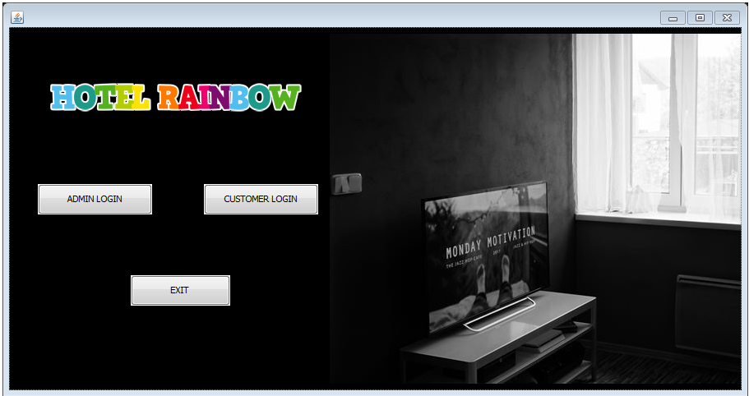

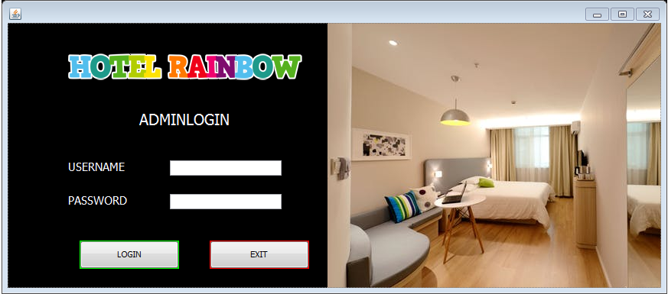

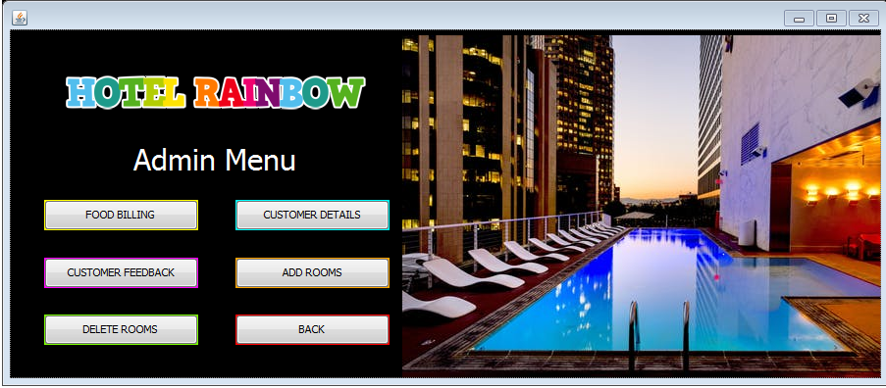

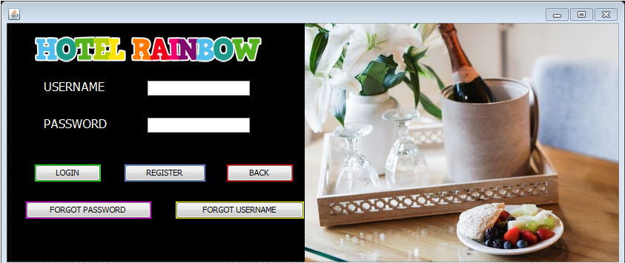

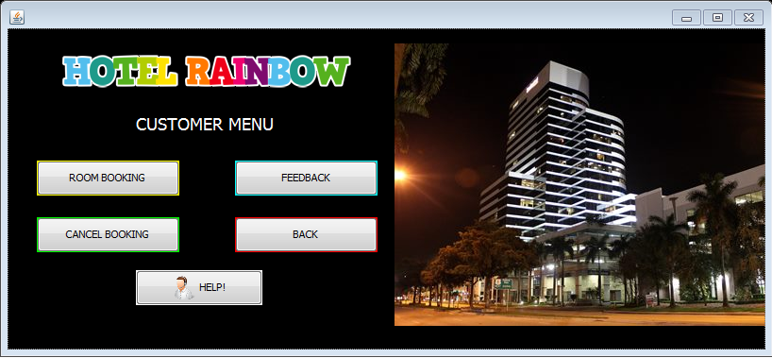

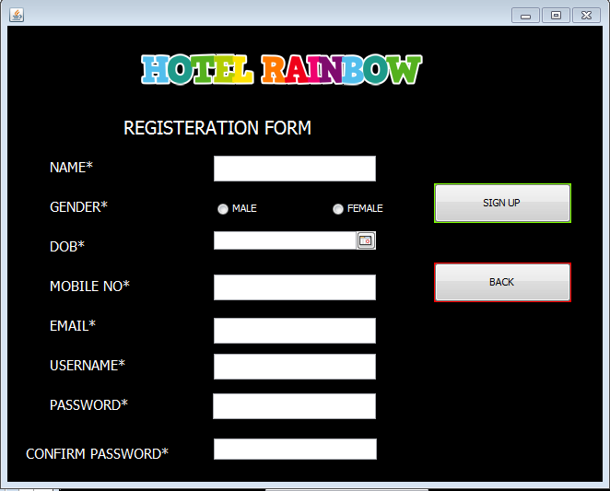

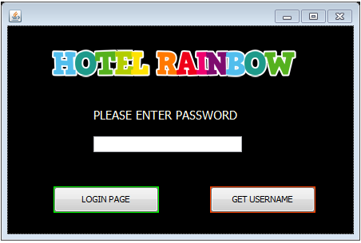

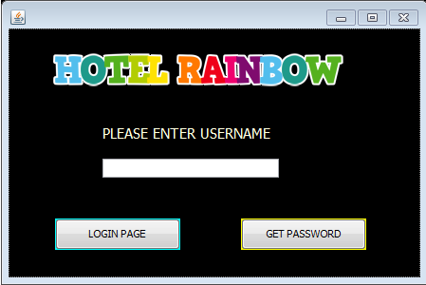

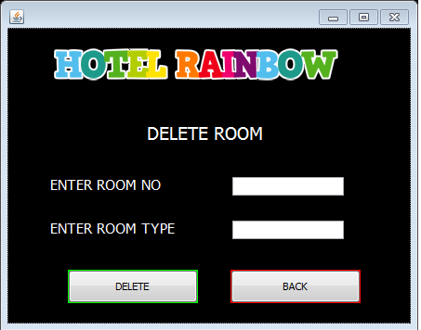

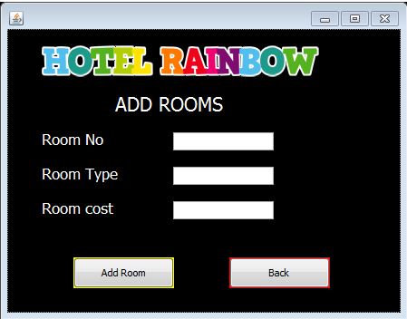

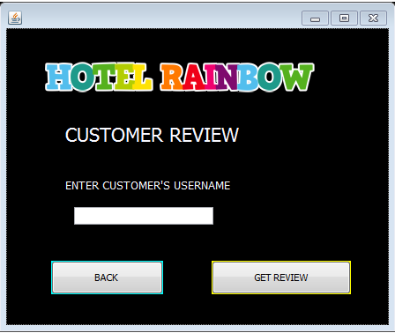

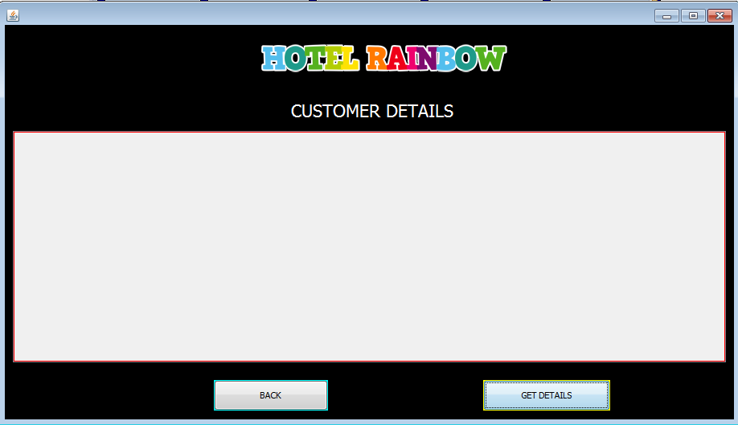

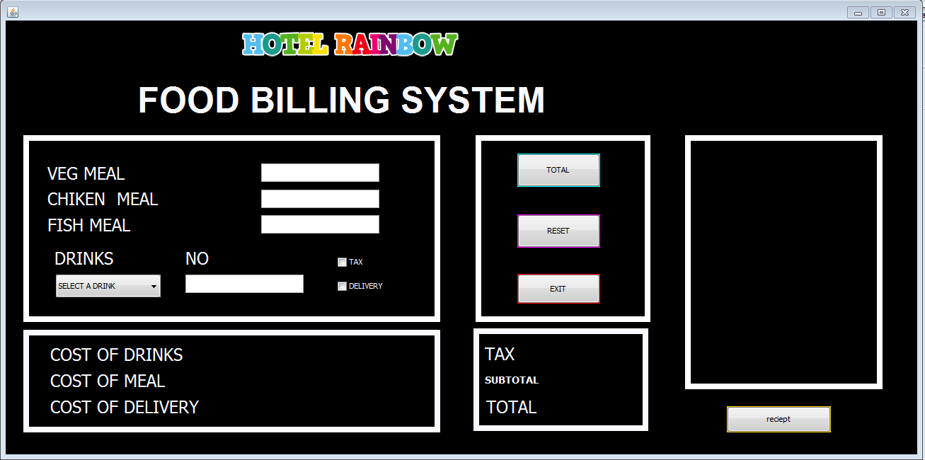

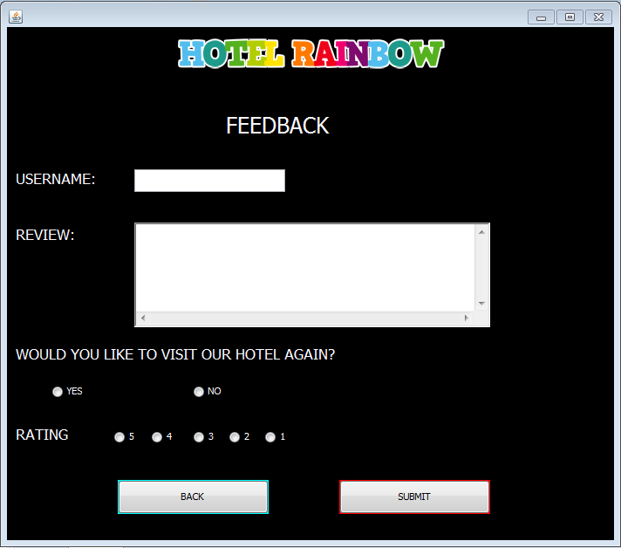

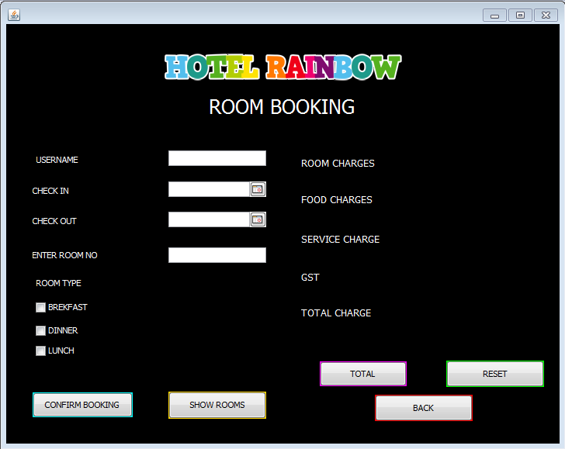

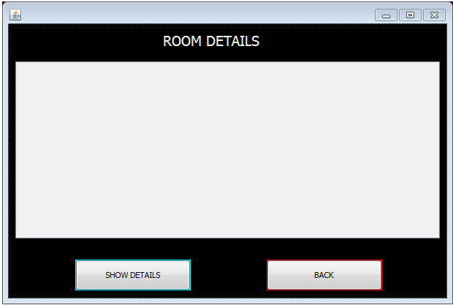

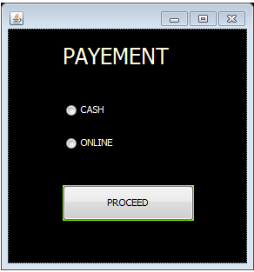

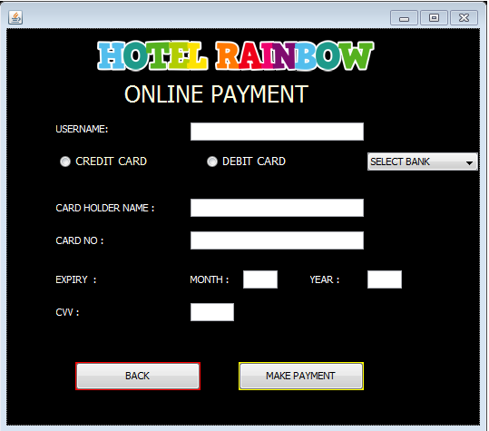

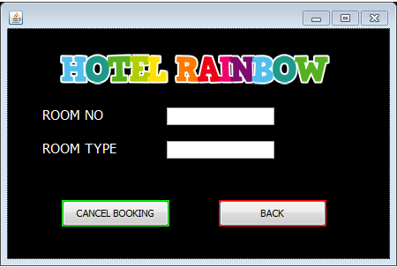

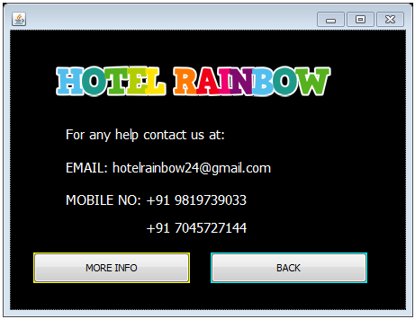

TESTING AND DEBUGGING

Testing is the process of executing the program with the intent of finding

errors and it establishes confidence that the program does what it supposes to do.

UNIT TESTING

It is testing of individual module.

INTERGRATION TESTING

Integration testing is performed after all the software units are combined

together. The objective here is to test the software interfaces.

**CONCLUSION**

Thus we have built a simple hotel management system using Java Eclipse. The program does some basic operations which can help a hotel manager manage hotel easily.